### AGGREGATE FUNCTIONs AND JOINs

## SUM and AVG

### SUM Function

SUM function returns the sum of a numeric column.

The syntax of the SUM function:

SELECT SUM(column_name)

FROM table_name;

Now, let's calculate the total amount of the salary of the employees in the company.

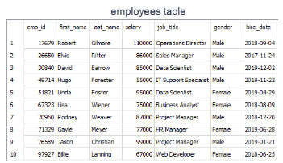

query:

SELECT SUM(salary) AS total_salary

FROM employees;

output:

total_salary

------------

836000

The amount of the total salary is $836,000. We can breakdown this into categories. For instance, we can find the total amount of salary of female employees.

query:

SELECT SUM(salary) AS total_salary

FROM employees

WHERE gender = 'Female'

output:

total_salary

------------

314000

**✍ Exercise:** Find the total amount of the salary for the male employees.

query:

SELECT SUM(salary) AS total_salary

FROM employees

WHERE gender = 'Male'

output:

total_salary

------------

522000

### 

### AVG Function

AVG function calculates the average of a numeric column.

The syntax of the AVG function:

SELECT AVG(column_name)

FROM table_name;

What is the average salary of the employees?   
  
query:

SELECT AVG(salary) AS average_salary

FROM employees;

output:

average_salary

------------

83600.0

The average salary of the employees is $83,600.  The total amount of the salary is $836,000. Since there are 10 employees, the average salary is $836,000/10 = $83,600. We just proved it.  
  
Now, let's find the average salary amongst male employees.   
  
input:

SELECT AVG(salary) AS average_salary

FROM employees

WHERE gender = 'Male';

output:

average_salary

------------

87000.0

**✍ Exercise:** Find the average salary for the female employees.

query:

SELECT AVG(salary) AS average_salary

FROM employees

WHERE gender = 'Female';

output:

avg_salary

----------

78500.0

### 